# Chapter 2: Stock Investing in a Nutshell

The most known ideas in stock investing, can be categorized in these two types of strategies:

***“Buy low, sell high”, & “Buy and Hold”***

But, how do we achieve that? And how can we perform even better? From the early beginning, I will say that I personally perform the Buy and Hold strategy (as any of the most successful investors in the world). However, to understand why, you will need to finish this little book!

Now that investment types have been defined on Chapter 1, it is time to go into the good stuff from this guide: “How to understand stocks”. Some investment books claim that stocks behave in a random matter [3]. **For this same reason, it is pretty much useless to try and predict which companies will go up and by how much. Generally speaking, this is true**. Many analysts apply what is called “Technical Analysis” in stock charts to create forecasts for the future behavior of the stock. In my personal experience, and based off research, technical analysis (also known as charting) **will not provide** you with any insightful information about the companies’ future performance (more into that later). However, **there is one thing that charts will help you** on (confirm it yourself if you doubt me). That is, **on selecting a stock as good candidate for investing or not.** In order to do this, we will look at the general trends of stocks. Overall, there are three main types of trends: Upwards, Downwards, and Horizontal Trends. Let us analyze each one of them. These might seem logical and boring, but we need to still cover the basics!

## Upwards Trends or “Bullish” Trends

**These trends are the best and most successful trends you can ever obtain.** Many investors recommend to always buy stocks that exhibit an upward trend. Given that the company is consistently increasing in value. An example shown is by famous Apple Company.

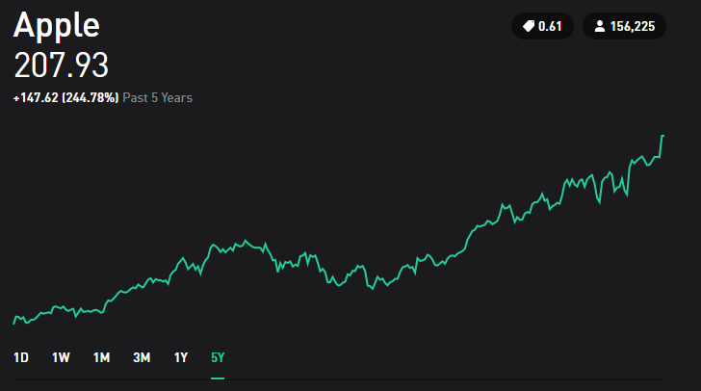

Apple’s Stock 2018

An upward trend, as the name implies is characterized by going up and it can be shown with a straight line (sometimes called linear approximation) as shown below. This trend tells us how well the company is doing based on how steep the line looks. With this method, it is now possible to make comparisons in between companies by simply looking at those lines. Now we will show 2 stocks that offer upward trends and their linear approximations (a single line that tries to follow the pattern) in blue to see how steep lines are.

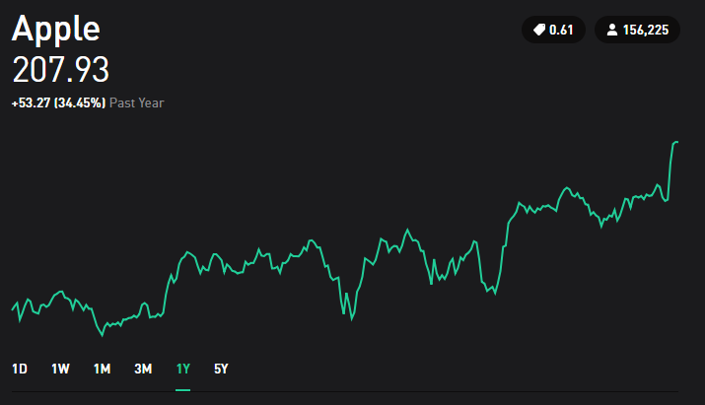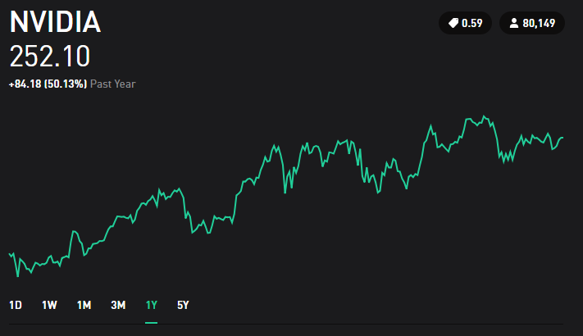

Comparison in between NVIDIA and Apples Stocks

Both show a linear increase, but it can be noticed that the linear approximation (in blue) for NVIDIA is steeper than Apple’s. Therefore, it would be determined that NVIDIA has shown more growth in their stock value. This can also be reinforced by looking at the percentage increases in both. Apple has 34.45% and NVIDIA has 50.13%. Even though this analysis seems simple, you can run through other platforms where information shows too many trends that can be really confusing for the beginner investors. To show how complicated this can get, let us see an example from Yahoo Finance that has some indicators.

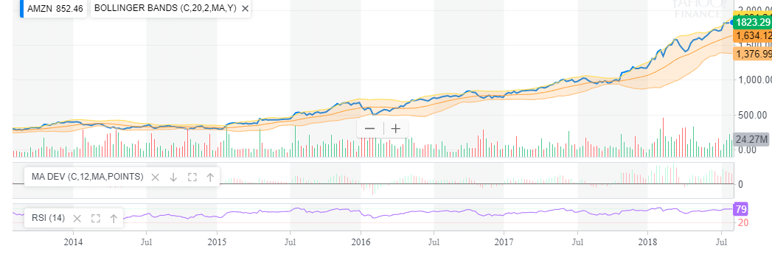

Amazon’s Stock from Yahoo Finance

This type of images should not discourage the early investors. **These types of charts offer many “charting tools” that are trying to be used to predict the future but most likely fail.** Even though the linear approximation technique is useful to get an idea how well the company is doing, **is a bad idea to use it in small time frames** (anything less than a year, for that, you would need to study something called day trading, which is very different).

When in doubt, always go back to the basics of identifying upwards trends. The key points to consider when looking at upwards trends are as follows:

* If you are comparing stocks, make sure they are being **compared at the same length of time**. Just as NVIDIA and Apple were compared earlier with 1 year of stock history, you need to always compare stocks with the same time of previous stock history. If you compare Apple’s history from last month to Microsoft’s history from last year to decide which one is better, you are not doing it right.
* Never be disappointed by daily changes. For this, we will take Spotify as an example.

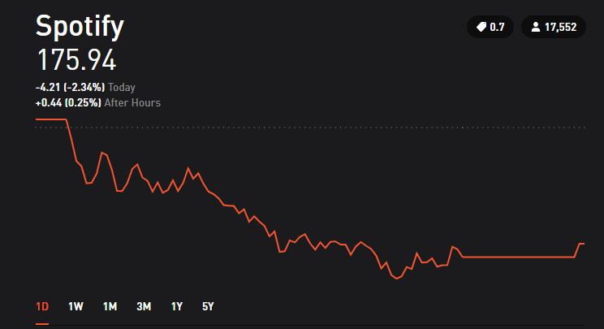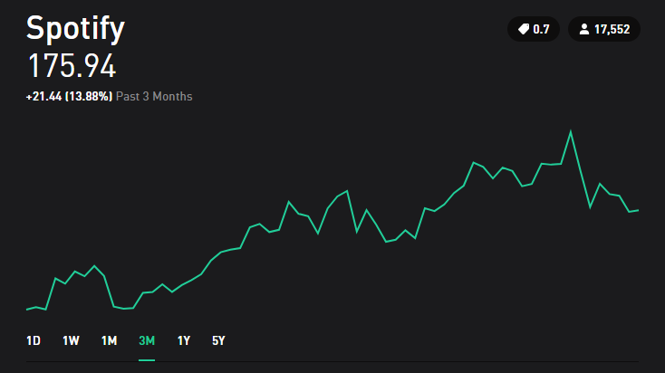

Spotify 1 Day vs 3 Month Trading history

If we look at Spotify’s trend for one day, it is obvious that the loss was considerably bad. However, if we look at the 3-month stock history, we notice how the stock in reality has generated 13.88% increase in price. So always remember that even **if the company has had a bad day, does not mean that is performing poorly**. Most of early investors get disappointed by buying stocks and then in one day or week start getting loses and decide to sell the stock before losing more money. However, if they start looking at the long-term information, they can deduct that the company has a high chance of giving return on the longer-term investments. **The longer the company has had their upward trend, the higher the chance that the company will keep giving you money on the long-term.**

* The reason why many investors don’t follow these ideas and start selling as soon as they see negative trends is because they are victims to their personal greed. Just as you must wait to grow a plant and obtain fruits, money works the same way. And even though it is possible to make fast money on the stock market, it is unlikely, hard to achieve, and even hard to maintain. So, the strategies and layouts on this guide serve for long-term investments for long-term wealth.
* One safe baseline is to **define upwards trends by at least 1 year of previous stock history**. However, if the company does not have that much time in the market, more research might be needed given that it can be risky to invest in something rather new. Many analysts identify these trends in small time frames such as even hours or days and we will see why that is not useful at all later in this section.

## Downward Trends or “Bearish” Trends

**These trends are the ones you need to avoid at all costs.** The reason to avoid these stocks is simply because they are going down. Some examples for downward trends are shown below.

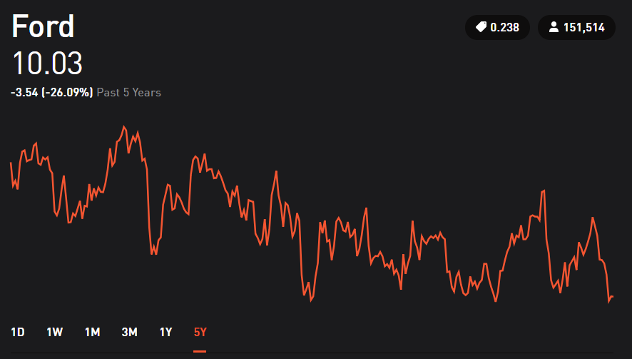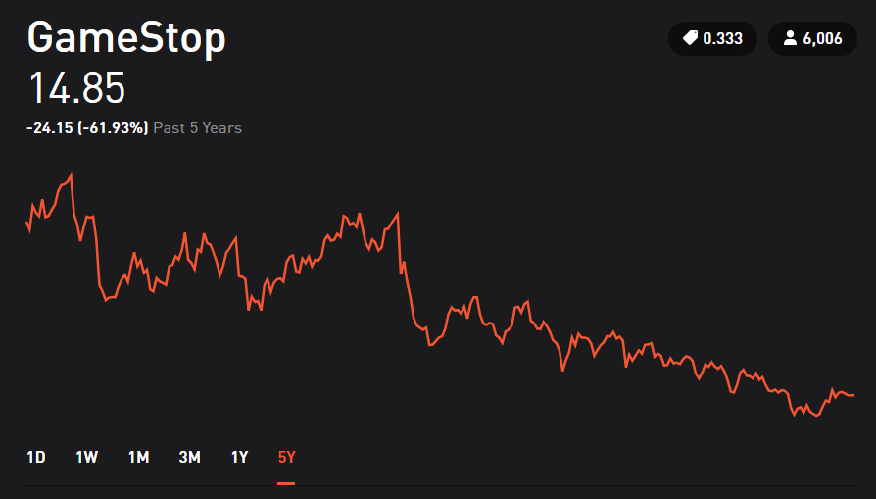

Downward Trend Examples

Some people argue that a downward trend is a sign that indicates that they will go up later. So, they buy the stock when price is decreasing, trying to find the exact time when it will start going up again. That is a good idea under very special considerations but not always!! (See Chapter 7: When to buy Low). Others argue that if the price once had a certain value, it must go back to that value eventually. **However, from personal research and experience, most (if not all) sources recommend avoiding this type of buying.** The reason behind it, is that there is too much risk involved in the company. Instead of trying to make money, people are focusing on just recovering back what they had from that same stock. This can be dangerous because it can bring obstinance in their behavior and start believing price changes that could never happen. When this happens, your emotions have clouded your mind. **Never let that to happen to yourself as an investor.**

I will pause myself and make a repetition for sake of importance: **You can bring obstinance in your behavior and start believing price changes that could never happen.**

This obstinate behavior is true for either long-term or short-term investments. Let us look at an example given by 22nd Century Group.

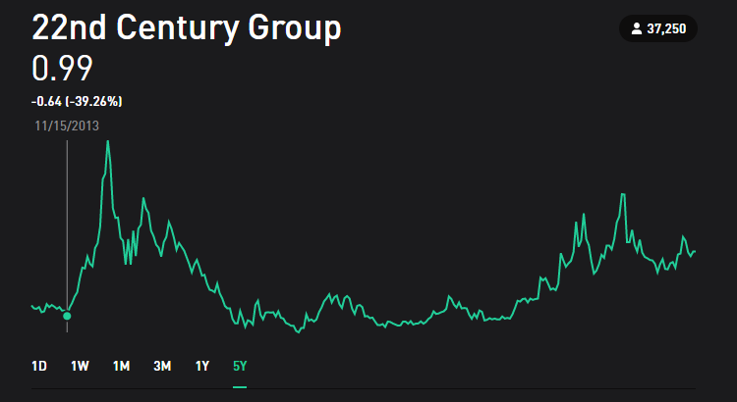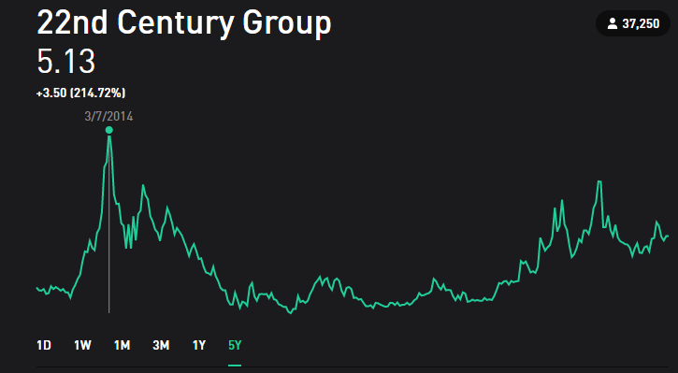

22nd Century Group in 2013 and 2014

**If you bought stock in 2013**, the value of it was about 1 dollar. After 4 months in 2014, the value of the stock grew 5 times of what it originally was. During this period, buying would be recommended. Excitement is high, and returns are good. Now let us look 4 months later, and 3 years later.

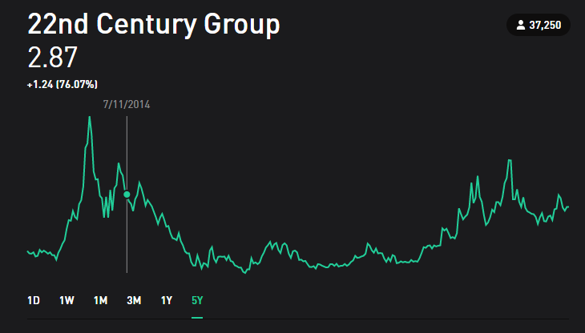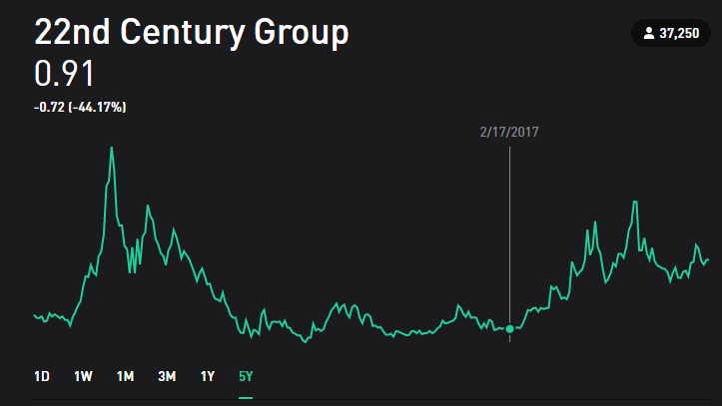

22nd Century Group in 2014 and 2017

Some investors way before this point of time would already have sold their stocks and kept their return instead of holding it longer waiting for more return. **But some investors could be on the idea that the price must go back to 5 dollars, even though they are on a downwards trend, decide to even buy more. That is not a wise move.** Three years later, the stock is valued even less than it was back in 2013. Looking at the history at 5 years, we can see how many investors won a lot of money and then some others lost a lot as well. This behavior of going down and then back up is possible, but is risky, that is why is not recommended for long-term investments.

How could you avoid this emotional roller coaster? Now in 2020, simply by looking at the long-term performance of the stock. The company back in 2013 did not have a long history of performance, and that short performance was negative. With that in mind, the company **would not** have been an option for investment since the beginning. There could be the claim that the spike that occurred in 2014 would be lost, and that is true. But remember, you are not playing lottery, you are making an investment. Sadly, many investors consider the “spikes” as winning a jackpot.

**Remember, investments need to be taken from a logical perspective rather than an emotional one.** Whether you are disappointed with loses, whether you are very excited with profits, it is always recommended to be calm and anticipate how things can change. Now, with all these in mind I invite you to maybe take a little break. Remember this book was not made to be considered a “one sitting” book.

Some Warnings

**For much as I don’t support short-term strategies, it is important to know they exists**. When you research for information about stocks, you will find words and definitions that are common among investors who use these “trading techniques”. Often coming from charting ideas, investors make claims about the future performance of many companies. Some examples include:

**Day Trading:** Focuses on finding upwards trends in short amounts of time (hours) and then buy when the price is predicted to keep going up. Then sell when the value of the stock is starting to decrease. The method is risky because requires constantly trading to generate profits.

**Swing Trading:** This trading strategy is like Day Trading but the amount of time for holding a stock is longer (usually days to weeks). This method involves the same idea of buying when the prices is predicted to keep going up for a couple of days and then sell when the value starts to decrease. This strategy is less risky than day trading but still riskier than traditional long-term investments.

**Trend Trading:** Very similar to Reversal Trading, but instead of going “up, down and then up”, the behavior can be quite different. The idea is to find a repeated pattern, could be a mixture of many ups and downs. After identifying this pattern, the objective is to buy the point of the pattern with the cheapest price and sell at the point with the highest price

**Momentum Trading:** Usually investors always seek to “buy low and sell high”. Momentum Trading instead focuses on trends that are “buying high and sell higher”. The time for this strategy can vary from hours to days. The longer a stock is hold, the longer the risk is.

**Reversal Trading:** Reversal means that the stock price is going up, then it goes down, and then will go up again. Investors that look for this pattern concentrate on finding the cheapest price before it goes back up. This technique again serves from hours to weeks. Similarly, to other strategies, the longer the stock is hold, the higher the risk it entails.

**Remember that if you want to use any of these strategies, you need to research in detail for the one you want to focus**. This was just an overview of some (but not all) strategies. Some people come up with their own trading style that is different from what exists. When it comes to these trading patterns, I often think of them as “noise”. Which is just something that comes out naturally out of information and is often undesired. For example, sometimes you will hear a beeping sound when you are turning a radio on (happened more often in old radios), or on vinyl record players (you will hear a static sound while the music is playing). All of those are examples of noise, but what you wanted to hear is the music coming out from those devices. So, stocks have also this “noise” to them which are the small patterns that are presented in the short-term duration, but it is the long term what you should be concerned about. Saying that a spike that occurred during one hour of trading is enough to predict the behavior for 1 year is like saying that the static you hear from the vinyl record told you what the song was all about. To end this little warning, I would like to quote Nate Silver: “Our brains, wired to detect patterns, are always looking for a signal, when instead we should appreciate how noisy the data is”.[3]

If the history of at least 5 years of the company is not a positive trend, it will not be a safe investment. It will be a risky investment with the chance of not making money. **The shorter the time history you are looking at. The higher the risk you are creating for your decisions.** That is the only “prediction” I can apply from chart data to my stock making decisions. Aside from that, everything else is just an empty promise of profits.

## Smaller Time Frame Trends

Depending on the amount of time history that you are looking, stock price can show different behavior. Taking Exxon for example:

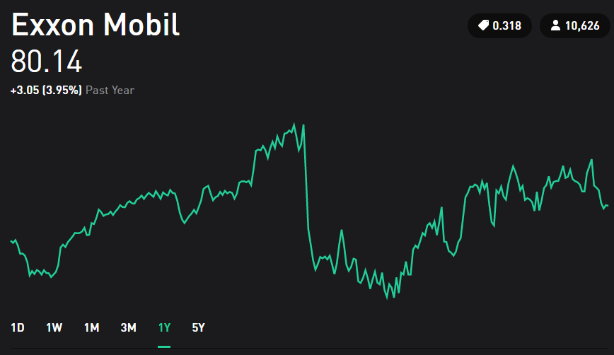

Exxon Mobil – 1 Year History

The behavior instead of being “horizontal”, it seems more like an upward trend, followed by a high decrease, and then another upward trend. If we were to split this graph into 2 sections where one represents 6 months, and the other one 6 months as well, both graphs would have an upward trend. **So many investors decide to break the history of stock prices into smaller sections to predict patterns at smaller time frames. This should always be avoided.** Trying to predict smaller time frames is what investment is not about.

Even though many trading strategies are created from the idea of recognizing patterns that will   
“predict” the behavior of the stock, there is simply too many factors that are not considered by solely looking at chart movement. Every company has fluctuations in the smaller time frames, and these fluctuations are pretty much unpredictable. Some people might claim to have predicted them, but when asked to predict multiple times, their “methods” will prove to be unsuccessful. There is an incredible amount of information and books that mention people who claim to have a predictive technique and end up failing in the long run [1][2]. Most of these methods include mathematical formulations and terminology for every type of curve movement you can imagine.

But now, think about it in terms of coin tossing, it is possible to predict certain number of outcomes (tails or heads), but after several times you will eventually fail. That same logic applies to the prediction of a small-time frame, some people might get it right sometimes, but not all the time.

Individuals who favor mathematical approaches (as I am one of them), will oppose the idea of not being able to use mathematical formulas for predictions. But we need to grasp that the main problem lies in the data itself. **Stock price history does not give enough parameters to make accurate predictions. It literally just tells you a price number at a point in time.** Furthermore, we have no way of measuring other parameters which bring uncertainty. What do I mean by that? Let us bring an example (this example might be too technical, but I will wrap it up with some important key points to understand it fully.

**Fundamental Example #1: Uncertainty, Risk and Measurability**

If you toss a coin, there is a 50/50 chance that you will obtain heads or tails. So, there is a 50% chance of you winning or losing. This “chance” is a measurement of risk.

All good? Let us make it more interesting. Imagine that you are in your friend’s house where you are playing dice. You are given a die and must guess the number that will appear after throwing it. If we want to measure risk, you will calculate a 1/6 chances or about 16.7% of getting it right. Now it is time to **add uncertainty** to the table. When you are doing this, you can let your mind turn into a spiral of thoughts. First, consider that you know the brand of the die, and you know from research that this brand is known to produce a smaller dimension in the number 4 face (otherwise known as manufacturing error). If that is the case, the die is not a perfect cube anymore, so it **creates an uncertainty**. Based on geometry, the die will lean to a specific direction. **But you don’t know which one, so you add uncertainty to your calculation**. This way your chances of getting it right might be lower to a 15%. This might not be accurate, but you know as a fact that manufacturing errors change the outcome of the die.

What else could go wrong? What would happen if your friends dog went ahead a eat the die while you were throwing it? How would you “calculate” the chances of your friend’s dog munching on your die? Well, this might not seem logical to consider, *but it is not impossible for it to happen*.

**Stocks works like that! If you are buying stock for a company, there is a humongous amount of uncertainties.** **How could you measure the likelihood of the company’s CEO stealing money from its own company? How about the likelihood of any member in the top position to be imprisoned for any reason you can think of? These questions might sound silly, but they do occur many times.** All these silly factors, if they were to occur, would damage the stock value of any company. **The moment that a situation like this occur, prices sink to incredibly fast, and no mathematical formulation can predict when is that going to happen.** Mathematics gives us an estimate, but if you don’t even have a basic measurement of uncertainty to start with, it is pretty much impossible to predict. Mathematics is a field that has brought us many incredible technologies by describing physics, but this does not mean it applies the same to stocks. Physics are described with mathematics because they follow the laws of nature. Stocks should not be described with mathematics because they follow the laws of human minds. This goes against our human tendency to have a mathematical formulation to explain everything. But at least, in a stock chart, there is no mathematical formulation that will predict its price tomorrow.

Does this mean that you should not invest because bad things occur? No. It means that should not believe any of the techniques for predicting stocks in small time trends and should focus on the long-term growth.

## What Affects Trends?

Just because we identify a trend does not mean that it will always stay that way. Sometimes the trends are affected for specific events that many people are not aware of. **It is important to note that a stock’s value reflects how well a company offers services or sell products.** So how their products are sold, how well their services are doing, how the public sees the company and many more factors affect these trends. And now the most important factor in this section: **Not everything about a stock can be predicted by looking only at the graphs.**

**Quick-Example #1 Popularity and Reputation Matter**: If you go to a place where customer service is excellent, the products are really popular and a lot of people you know shop or pay services on this company, then you already have many good signs of how the stock of company should be doing. On the contrary, if the company you are analyzing, has really bad reviews, people don’t ever or stopped going to this company, you can see that this behavior are heavily reflected on the company’s stock. Let us take for product example: Netflix and Blockbuster. Nowadays, everyone has a Netflix account. Most people when talking about movies or series, they refer to Netflix or similar competitors. On the other side, Blockbuster is a company that recently reached bankruptcy. However, for the past 5 years that it was still on the market, nobody would ever mention it, it was uncommon to hear about people going to buy products at Blockbuster.

**Quick-Example #2 Some Businesses are Season-Dependent:** Stocks are representative of a business. So there exists businesses where the time of the year is significant. If you go to a clothing store that focuses on selling winter clothing, then you would not be surprised to see that the earnings of the company and stock prices usually are higher on winter seasons, and then low on summer seasons. Pay attention to the seasons in which businesses work.

The factors that affect trends, are too many to just explain in one chapter. The idea of this chapter was to explain how different trends are identified and how they behave. **The final note on this chapter is to always remember that the time frame that we look at things plays a huge role in our understanding of stocks.** Furthermore, there are other key things to understand before developing a complete strategy in stock trading. These key things are the next chapter.

Based on our beginning chapters, a good investor understands:

* That companies issue stock for sell to sustain their business and grow.
* How Stocks’ charts can only help to select some companies on basis of long-term growth.
* That smaller time frames provide with too many uncertainties to predict them at all (which is why all these “charting techniques” do not work.